CONSULTANCY SERVICE AGREEMENT

This CONSULTANCY SERVICE AGREEMENT (the “Agreement”) is entered into on this (FULL DATE), by and between:
- Agnivridhi India, hereinafter referred to as the Service Provider, having its principal place of business at Lg-02, H-165, Sector 63, Noida, Gautam Buddha Nagar, Noida, Uttar Pradesh, India, 201301;
and
- (COMPANY NAME) hereinafter referred to as the Service Receiver, having its principal place of business at 202, Vandana Golden Springs, Near Ryan International School, (COMPANY ADDRESS).
WHEREAS, the Service Provider agrees to provide consultancy services for assisting the Service Receiver in raising Private Funding by facilitating investor outreach, investor introductions, investor meeting coordination, pitch presentation support, and related consultancy services.
1) Definitions
a) Agreement: Refers to this Agreement and all annexures or amendments made in writing and mutually agreed upon by both parties.
b) Service Provider: The party providing the consultancy services in exchange for payment.
c) Service Receiver: The party receiving and availing the consultancy services.
2) Covenants of the Service Provider
a) review and assist in preparation of Pitch Deck, Business Profile, Financial Projections, Investor Memorandum, and other documents required for investor discussions under the CONSULTANCY SERVICE based on the information and data received from the Service Receiver. Upon request, the Service Provider may also submit the application on behalf of the Service Receiver.
b) The Service Provider agrees to maintain strict confidentiality of all information and documents provided by the Service Receiver and shall not disclose them to any third party except authorized personnel.
3) Covenants of the Service Receiver
a) The Service Receiver acknowledges that the registration and application process is subject to change as per applicable norms and has no objection if delays arise due to such changes.
b) The Service Receiver agrees to pay a Consultancy fee of ₹(PITCHED BY THE SALES PERSON) as per the following structure:

- Stage 1: ₹(TOKEN MONEY RECEIVED) as token money, payable at the time of signing this Agreement.
- Stage 2: ₹(PAYMENT REMAINING) At the time of Interview
- Stage 3: (DISPERSMENT RATE)% as success fee of the funded amount, payable after the disbursement.
c) The Service Receiver shall provide all required documents requested by the Service Provider for processing the application.
d) Refund Clause:
- All payments made to Agnivridhi India are strictly non-refundable once services have commenced.
- Delays or rejections by the bank or authority will not constitute grounds for refund
Services will commence only after signing this Agreement.
e) All payments must be made only to Agnivridhi India’s official bank account.
- The Company shall not be responsible for any payment made which is not mentioned in this agreement payment terms.
- Such payments will not be recognized or refunded by the Company.
4. Funding Process
The funding process shall include:
• Business Profile Review.
• Pitch Deck and Financial Review.
• Investor Identification and Outreach.
• Coordination with prospective Investors.
• Scheduling Investor Meetings.
• Facilitation of Investor Discussions.
• Follow-up regarding Investor Feedback.
The process flow shall generally follow:
Business Review → Investor Outreach → Investor Meeting → Investor Evaluation → Funding Decision
The Service Provider's role shall remain limited to facilitation and coordination only.
5. Funding Eligibility
Funding eligibility shall depend upon:
• Business viability.
• Revenue model.
• Management capability.
• Financial performance.
• Market opportunity.
• Investor preferences.
The Service Provider shall not be responsible for rejection by any investor.
6. Investor Evaluation
The Service Receiver acknowledges that investors may independently conduct due diligence, financial review, management assessment, and market evaluation before making any investment decision.
7. Duration & Processing Timeline
Investor funding timelines depend entirely upon investor evaluation and internal decision-making processes.
The Service Provider shall not be responsible for delays caused by investors, due diligence requirements, negotiations, or market conditions.
8. Documentation & Procedures
The Service Receiver shall provide:
• Pitch Deck
• Financial Statements
• Company Profile
• Business Plan
• Incorporation Documents
The Service Provider shall assist in reviewing and organizing such documentation.
9. Company Duties & Responsibilities
Agnivridhi India shall:
Review funding documents.
• Approach suitable investors.
• Coordinate investor communications.
• Schedule a maximum of Two (2) Investor Meetings.
• Facilitate discussions between investors and the Service Receiver.
The Company's responsibility is strictly limited to consultation, investor introductions, meeting coordination, and facilitation only.
The Company does not guarantee funding, investment approval, valuation, or issuance of any term sheet.

10. Client Duties & Responsibilities
The Client must:
- Provide accurate information and documents.
- Respond promptly to all communications.
- Bear all government, bank, and third-party fees directly if applicable.
Failure to cooperate may result in delay or termination of service without refund.
11. Investor Decision Process
The Service Receiver understands that:
• The final funding decision shall rest solely with the Investor.
• Investors may approve, reject, delay, negotiate, or withdraw from investment discussions at their sole discretion.
• The Service Provider has no authority to influence investor decisions.
• The Service Provider's obligations shall be deemed substantially fulfilled upon scheduling and coordinating up to Two (2) Investor Meetings.
12. Time Limitation & Workflow
The estimated duration for investor outreach and meetings may vary depending upon investor availability and response time.
The Service Provider shall not be responsible for delays caused by investors or external parties.
13. Liability Disclaimer
The Company shall not be liable for:
The Company shall not be liable for:
• Investor rejection.
• Investor withdrawal.
• Funding delays.
• Valuation disagreements.
• Failure to secure funding.
• Investor due diligence observations.
• Commercial terms proposed by investors.
• Any financial loss incurred by the Client.
14) Term
This Agreement automatically expires if the Service Receiver fails to provide required documents or information within 30 days from the date of signing.
In such cases, no refund or adjustment will be applicable.
This Agreement shall be valid for a period of three (3) months from the date of execution, unless terminated earlier in accordance with the terms herein.
15) Termination
a) Either party may terminate this Agreement by giving a 30-day prior written notice.
b) Immediate Termination: The Service Provider reserves the right to terminate this Agreement with immediate effect if the Service Receiver fails to comply with any clause of this Agreement.
c) Termination shall not affect the Service Provider’s right to claim payment for services rendered up to the termination date.
16) Relationship
This Agreement does not create any employment, agency, or partnership relationship between the parties. Each party is an independent contractor.
17) Third Parties
This Agreement does not grant any rights or claims to third parties.
18) Modification
Any changes to this Agreement must be made in writing and signed by both parties.
19) Severability
If any clause is held to be invalid, the rest of the Agreement remains enforceable and in effect.
20) Enforcement and Waiver
Failure to enforce any part of this Agreement does not constitute a waiver of that part in the future.
21) Effective Date
The effective date of this Agreement shall be (DATE DD/MM/YYYY), regardless of the actual date of signature.
22) Governing Law
In the event of any dispute or disagreement arising out of this Agreement, the same shall first be resolved through mutual discussion.
If unresolved within 15 days, it shall be referred to a sole arbitrator appointed mutually under the Arbitration and Conciliation Act, 1996.
The arbitration shall be conducted in English at Delhi.
23) Notices
All notices shall be sent via registered post or email to the addresses mentioned or last known.
24) Entire Agreement
This document constitutes the entire agreement between the parties and supersedes all prior communications.

25) Counterparts
This Agreement may be signed in counterparts, all of which together will constitute one agreement.
26. Acceptance & Acknowledgment
The Service Receiver acknowledges and agrees that:
a) Agnivridhi India Private Limited acts solely as a consultant and facilitator.
b) The Service Provider is responsible only for investor outreach, coordination, and scheduling of up to Two (2) Investor Meetings.
c) No guarantee of funding, investment, valuation, approval, or timeline has been provided.
d) The final decision regarding investment shall rest solely with the Investor.
e) Investor rejection, delay, withdrawal, or non-investment shall not constitute grounds for refund, compensation, or legal claim against the Service Provider.
f) Upon scheduling and coordinating Two (2) Investor Meetings, the Service Provider's primary obligations shall be deemed fulfilled.

IN WITNESS WHEREOF, the undersigned have executed this Agreement on the day and year first written above.
Signed and delivered for and on behalf of | I have read and understood the provisions of this Agreement & hereby accept the same.
Name: Agnivridhi India Private Limited | Name: (COMPANY NAME)
Title: Director | Title: Director
Date: (DATE DD/MM/YYYY) | Date: (DATE DD/MM/YYYY)
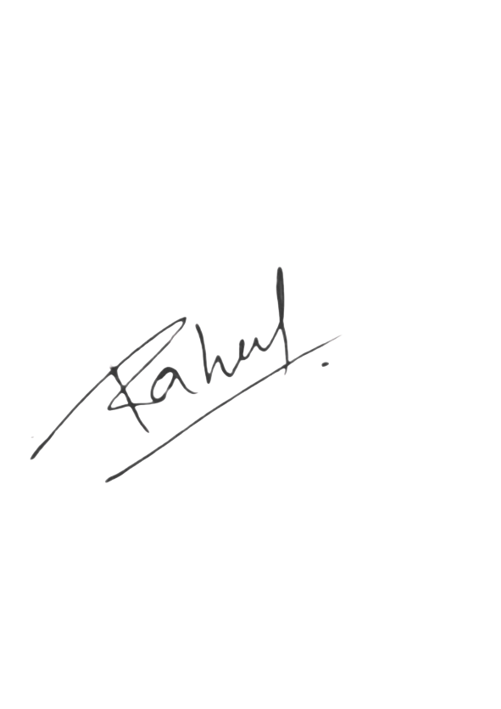  Signature: | Signature:

UNDERTAKING
I, the Director/Partner of (COMPANY NAME) do hereby undertake as follows:
i. That I shall fully comply with all the sub-clauses stated under Clause (3) of the Consultancy Service Agreement. Any failure to do so shall result in immediate termination of this Agreement and forfeiture of the amount paid.
ii. All official communications shall be through the company’s registered email domain (Legal@agnivridhiindia.com) or via written letters.
Communications or commitments made via WhatsApp, calls, or personal chats will not be considered official or binding.
iii. I understand and acknowledge that providing false, misleading, or incomplete information will render this Agreement voidable at the sole discretion of the Service Provider and the fee shall be non-refundable.
iv. I hereby confirm that I have read, understood, and accepted all the terms and conditions mentioned on the official website of the Service Provider at www.agnivridhiindia.com, as well as those laid out in this Agreement.

